CASEY SORRELLS
Task 2

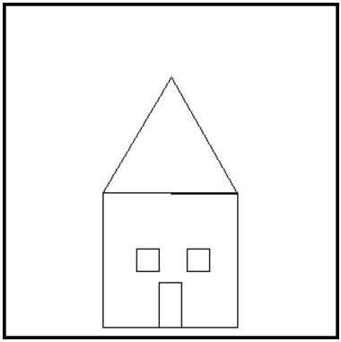
GO BOTTOM
GO SQUARE

POINT 0
MOVE 30
POINT 90
MOVE 50

GO WINDOW
POINT 0
MOVE 45
POINT 90
GO WINDOW

MOVE -50
POINT 180
MOVE 25
POINT 90

GO DOOR
GO BOTTOM

MOVE 120
POINT 180
GO TRIANGLE
END

# WINDOW
REPEAT 4
DRAW 20
RIGHT 90
NEXT
RETURN

# DOOR
REPEAT 2
DRAW 40
RIGHT 90
DRAW 20
RIGHT 90
NEXT
RETURN

# SQUARE
REPEAT 4
DRAW 120
RIGHT 90
NEXT
RETURN

# TRIANGLE
REPEAT 3
RIGHT 120
DRAW 120
NEXT
RETURN

# BOTTOM
HOME
POINT 90
MOVE -140
POINT 180
MOVE 60
POINT 90
RETURN

